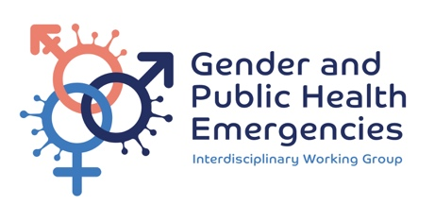

GENDER AND PUBLIC HEALTH EMERGENCIES

Small grants Application form

N/B: please fill out the form below. In additional to the overall excellence of the proposal we will be taking into consideration the diversity of applicants.
APPLICATION DETAILS
Applicant Organization:
Country:
Project title:
Organization tax identification/registration number:
Website URL:
Principal investigator:
Title / Occupation of PI:
How do you (PI) describe yourself in terms of Gender:
How do you (PI) describe yourself in terms of Race/ethnicity:
Is there anything else about yourself which you want to disclose?:
Other team members (please list name and organization for each):
Project Implementation Country
Duration of proposed project:

RESEARCH/ PROJECT DESCRIPTION
- What area of the small grants call does your research/project respond to? Explain why this is needed (300 words maximum)
- List your research/project objectives (150 words maximum)
- Where will the research/project be conducted? Please name the countries, identify the research or project sites within the countries, and offer a brief rationale (150 words maximum)
- Who are your research participants/project target and how were they involved in design of your research/project (150 words maximum)
- Explain how your proposed research/project will strengthen the objectives and goals of the Gender and Public Health Emergencies Working Groups. What will success look like? (200 words).
- What are the potential challenges you may face during the research/project?
Please include a discussion of mitigating strategies (planned and potential) (200 words Maximum)
- Explain how your research/project fits into existing health systems or interventions, including other donors, government programmes with specific focus on future scale up (250 words maximum)
- How are you planning to communicate about your research/project? (150 words maximum
- Submit a budget (in USD) and action plan with a proposed timeline to this application

